**Coding Assessment – MongoDB**

**Relationships in MongoDB**

* One-to-One Relationships
* One-to-Many Relationships
* Many-to-One Relationships
* Many-to-Many Relationships

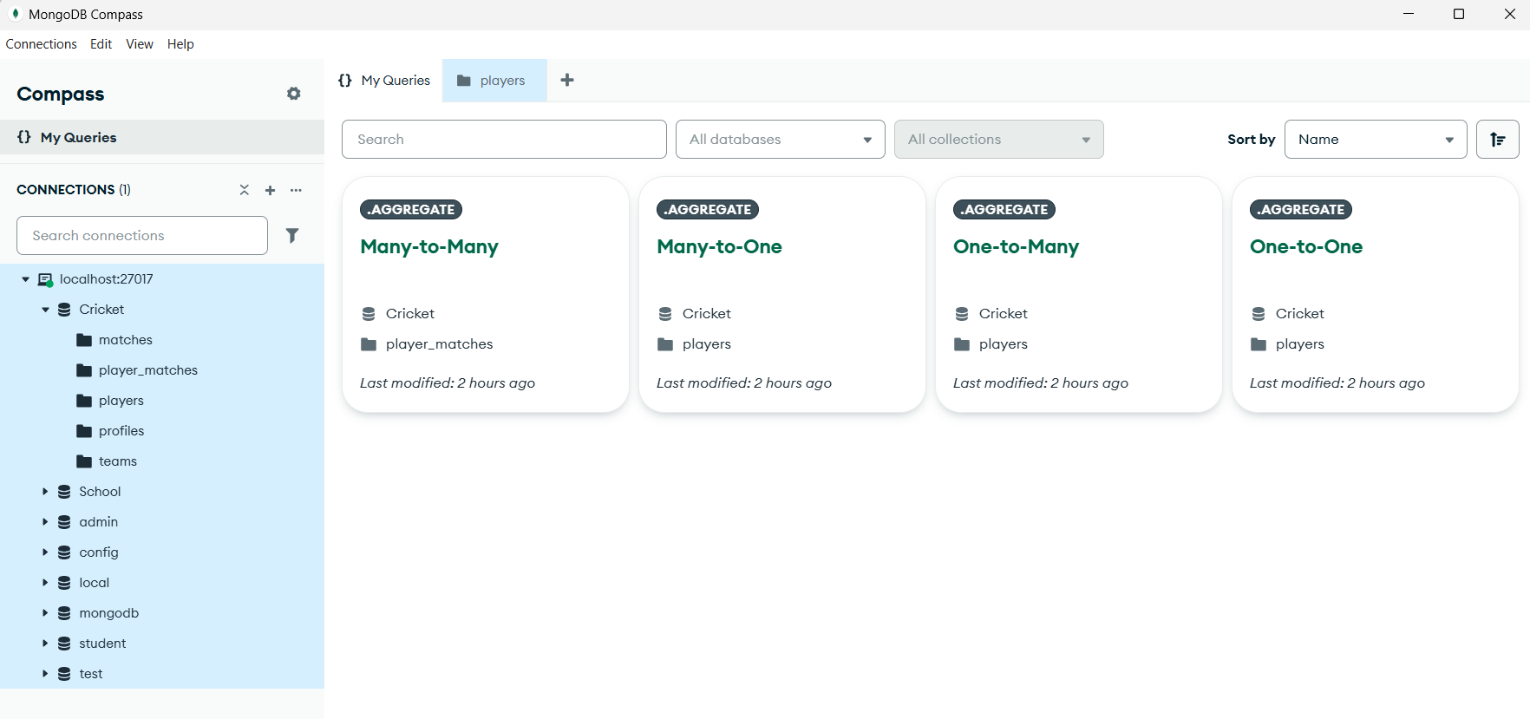

**Collections**

* players
* profiles
* matches
* teams
* player_matches

**players collection with inserted Documents**

{"_id": 1,

"name": "Virat Kohli",

"role": "Batsman",

"team_id": 1}

{"_id": 2,

"name": "Jasprit Bumrah",

"role": "Bowler",

"team_id": 2}

{"_id": 3,

"name": "Rohit Sharma",

"role": "Batsman",

"team_id": 1}

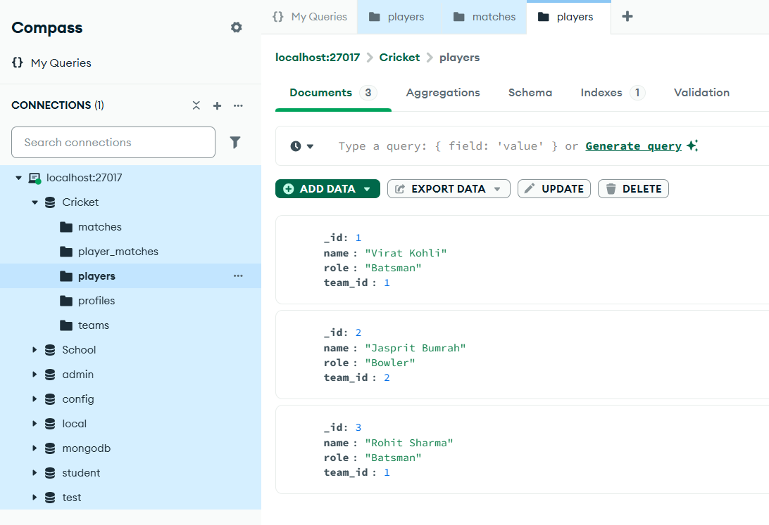

**matches collection with inserted documents**

{"_id": 1,

"match_date": "2025-07-25",

"teams": [

"India",

"Australia"]}

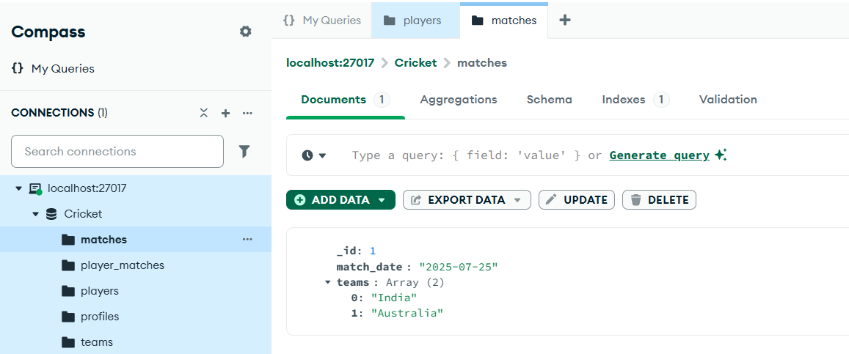

**profiles collection with inserted documents**

**{**

"_id": 1,

"player_id": 1,

"age": 35,

"country": "India"

}

{

"_id": 2,

"player_id": 2,

"age": 30,

"country": "India"

}

{

"_id": 3,

"player_id": 3,

"age": 36,

"country": "India"

}

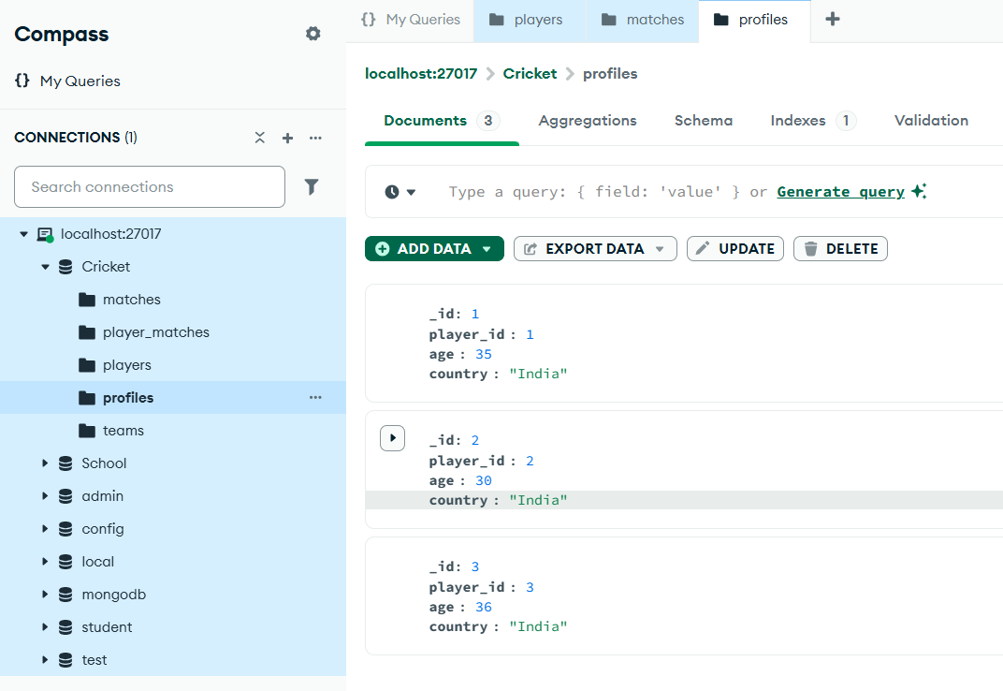

**teams collection with inserted documents**

{

"_id": 1,

"team_name": "India"

}

{

"_id": 2,

"team_name": "Australia"

}

{

"_id": 3,

"team_name": "India"

}

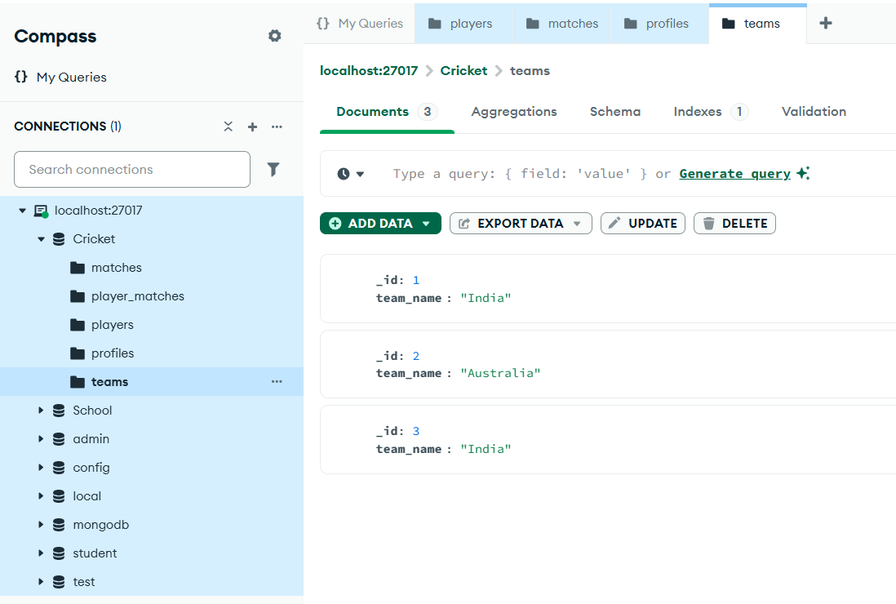

**players_matches collection with inserted documents**

{

"_id": 1,

"match_id": 1,

"player_id": 1

}

{

"_id": 2,

"match_id": 1,

"player_id": 2

}

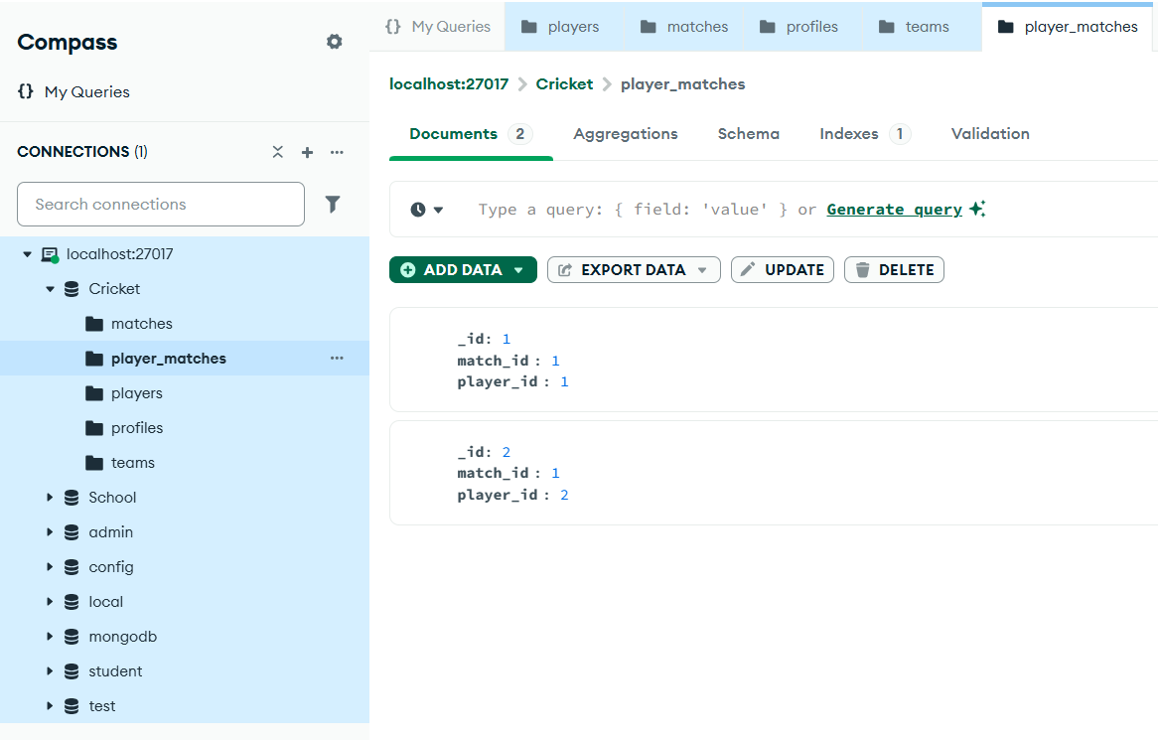

**MongoDB Relationships**

1. **One-to-One**

**$lookup**

{

from: "profiles",

localField: "_id",

foreignField: "player_id",

as: "profile"

}

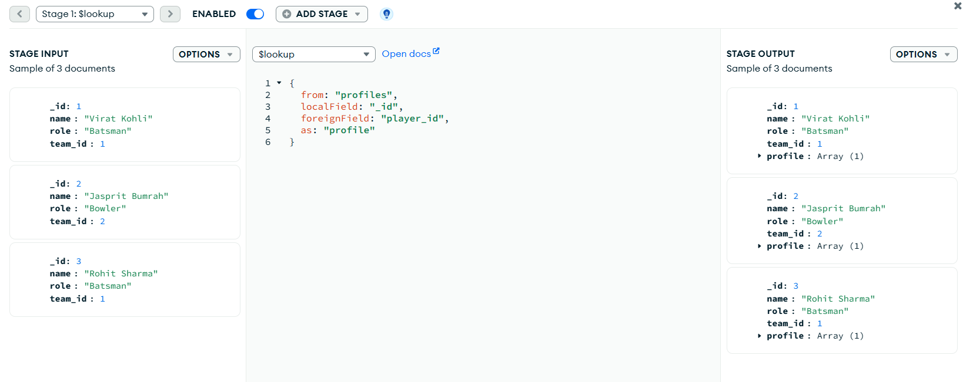

1. **One-to-Many**

**$lookup**

{

from: "teams",

localField: "team_id",

foreignField: "_id",

as: "team"

}

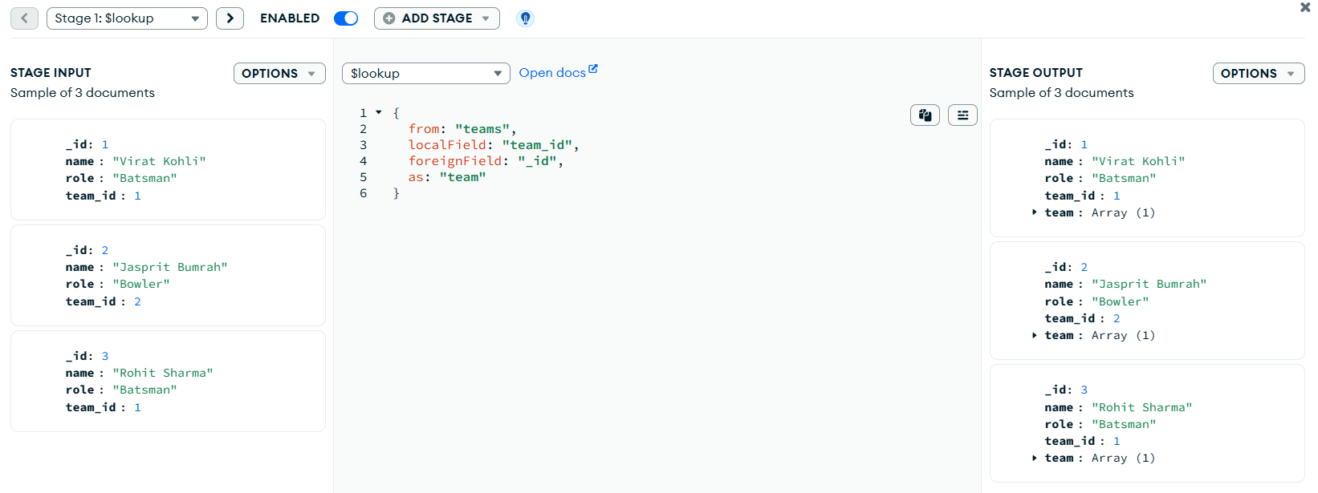

**$match**

{

"team.team_name": "India"

}

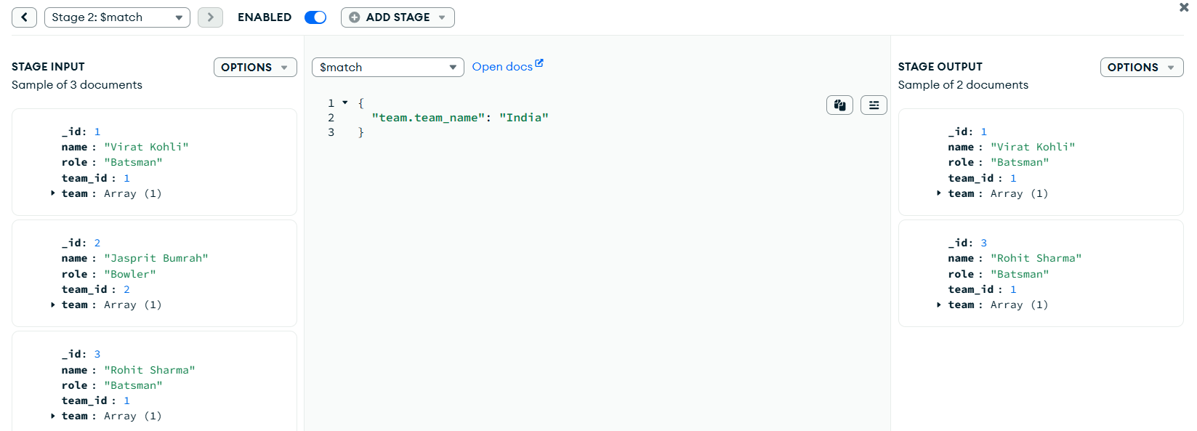

1. **Many-to-One**

**$lookup**

{

from: "teams",

localField: "team_id",

foreignField: "_id",

as: "team"

}

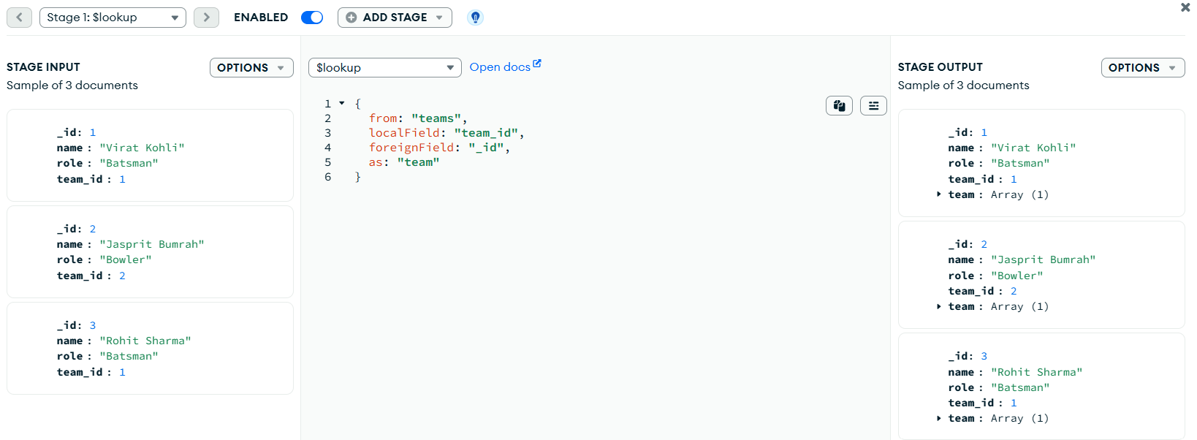

1. **Many-to-Many**

**$lookup**

{

from: "players",

localField: "player_id",

foreignField: "_id",

as: "player"

}

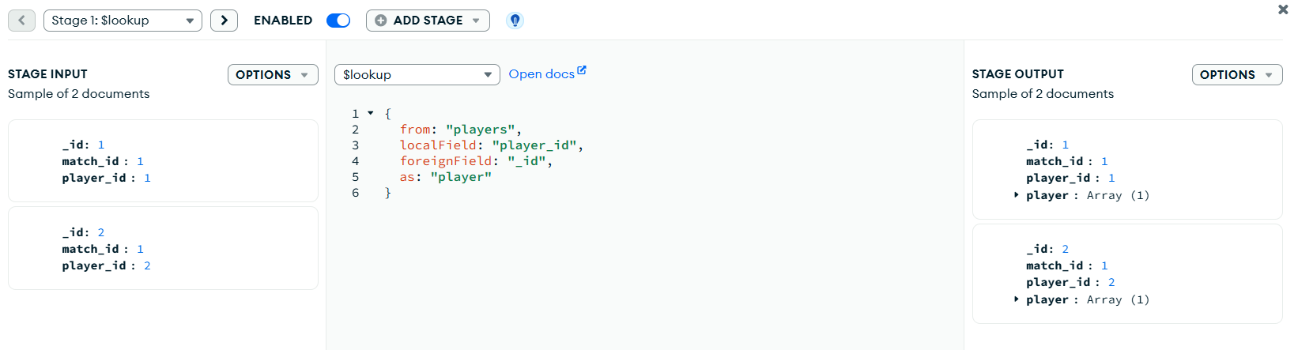

**$lookup**

{

from: "matches",

localField: "match_id",

foreignField: "_id",

as: "match"

}

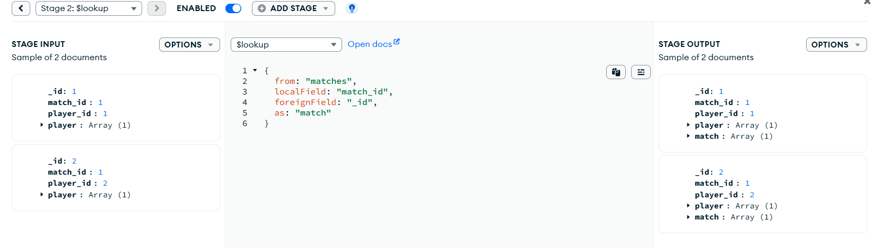

**Submitted by**

Siva Balan T